Blacksmithing/Metalworking

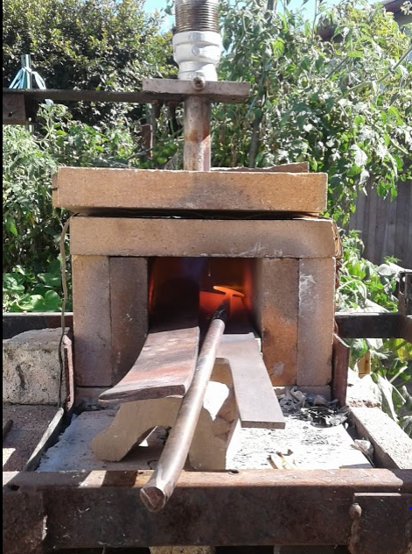 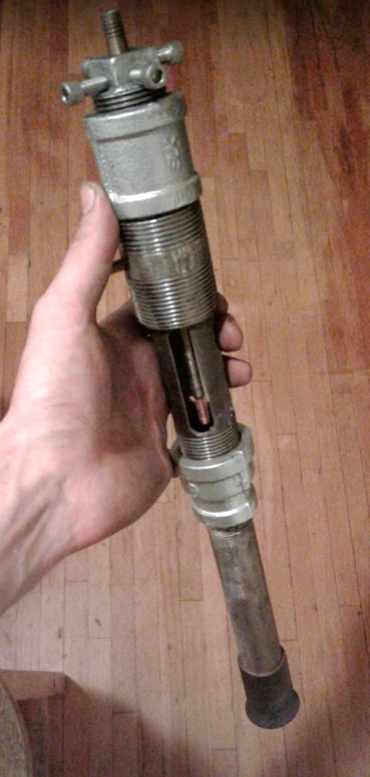

This is a gas forge and a venturi propane burner I built. Ive been smithing for over 10 years, and have made everything from sledge hammers to steel roses. The forge shown here is an older version from a few years ago. Ive since switched out burners, changed fire brick type (to a soft insulating 2600 F brick), and mounted the burner at an angle to increase air circulation in the chamber.

Here are just a few of the projects I’ve worked on over the years!

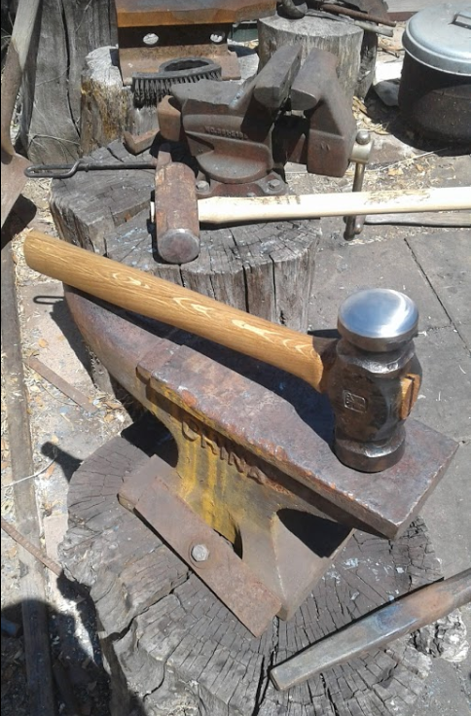 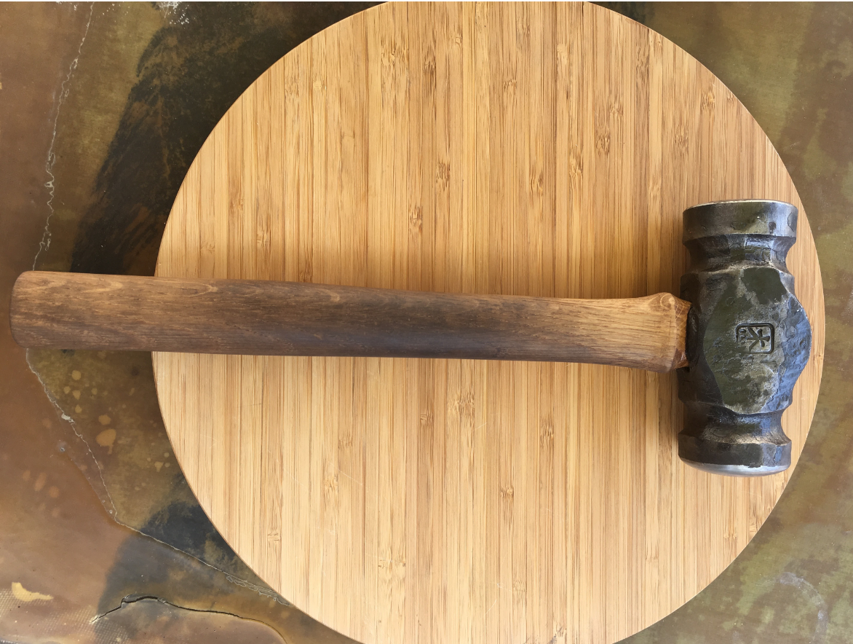 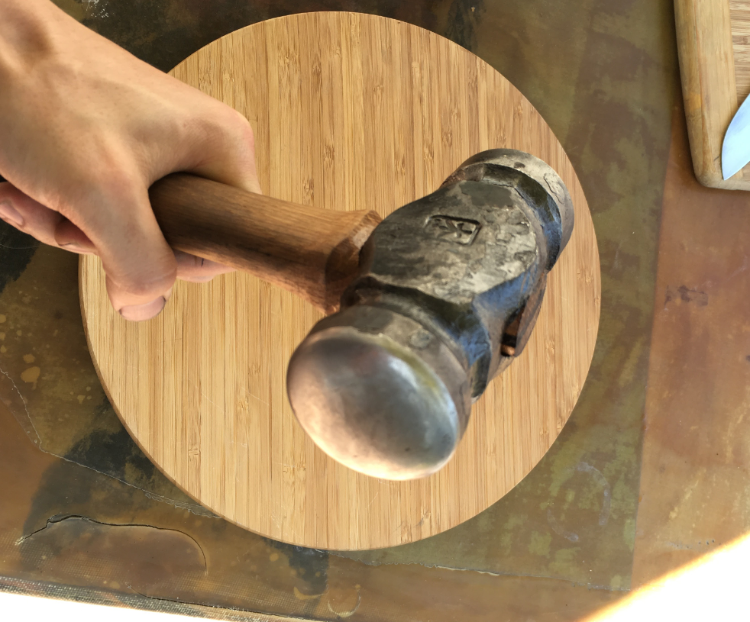

This is a 4.5 lb rounding hammer. Its made from 2” round 1045 quenched and tempered steel.

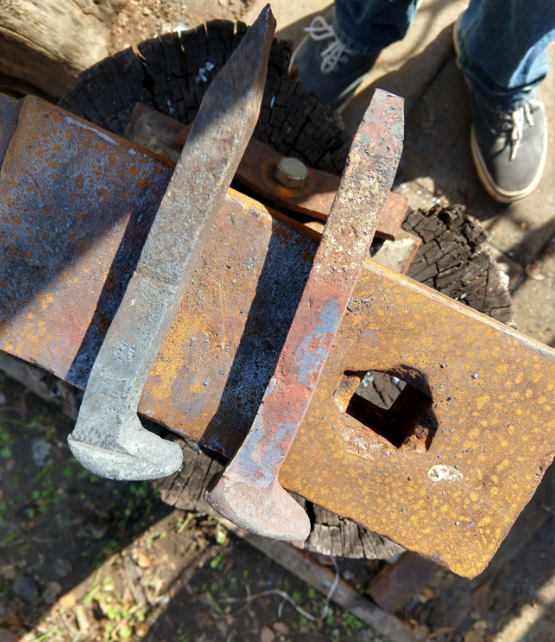 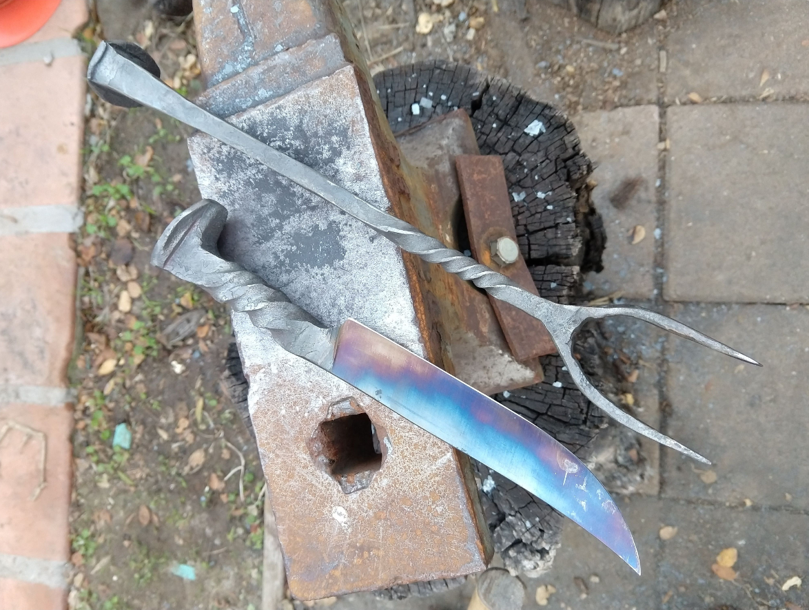

This is a BBQ set I forged from 2 railroad spikes. The colors on the blade are a thin oxide layer that forms when steel is heated. For a specific alloy, the color indicates the temperature and is sometimes used as a reference when tempering a blade. This piece was mainly decorative, so I tempered at a higher temperature than I normally would to get some bright blues.

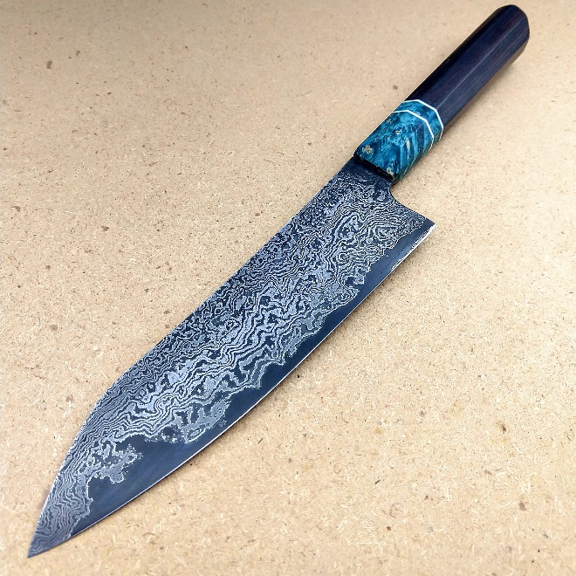 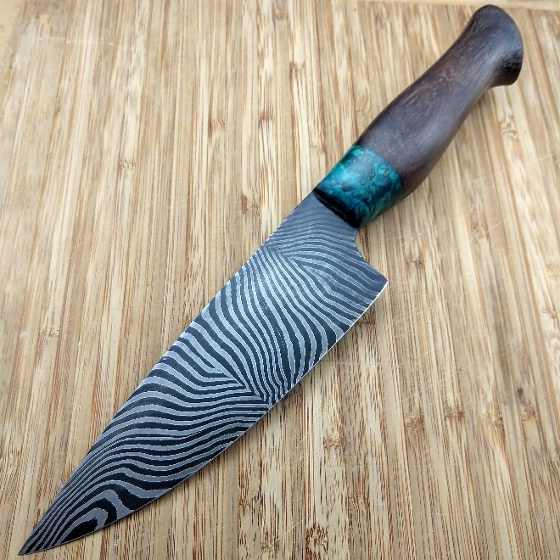

Here are 2 Damascus (pattern welded) blades that I made. The pattern is formed by layering 2 dissimilar steel alloys together and “forge welding them into a solid billet. Forge welding is a type of solid state welding what allows for complete bonding of 2 surfaces. The billet can then be manipulated, ground and then etched to expose a specific pattern. Steels need to be chosen so that they react with the etchant differently to get high contrast pieces. On both knives 8670 and 15n20 steels were used. The high nickel content in 15n20 resists the etchant leaving raised bright layers. The layering and folding technique used on pattern welded blades was traditionally done to unrefined steel to make it into a more homogeneous material (often done on Japanese swords) however with modern steel manufacturing techniques this is no longer necessary and is done purely for visual effect.